1>WAP in Java to print the Fibonaaci series

2>WAP in Java to check if a number is prime or not

3>WAP in Java to find the factorial of a number

4>WAP in Java to check if a number is armstrong or not

5>WAP in Java to find reverse of number and check whether palindrome or not

6>WAP in Java to find largest bw five numbers in Java

7>WAP in Java to find the sum of all even number from 1 to 20

8>WAP in Java to find the Amount and SI for P=50000, t=6 years, r=4%

9>WAP in Java to find GCD of two numbers

10>WAP in Java to find the sum of all odd number from 12 to 20

11>WAP in Java to print the Diamond pattern

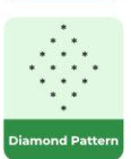

12>WAP in Java to print the below

